**MarcheGains Installation and User Manual**

1. Installation Process
   1. Download the entire compressed (zipped) folder from source.
   2. Decompress the MarcheGains folder to reveal the product.

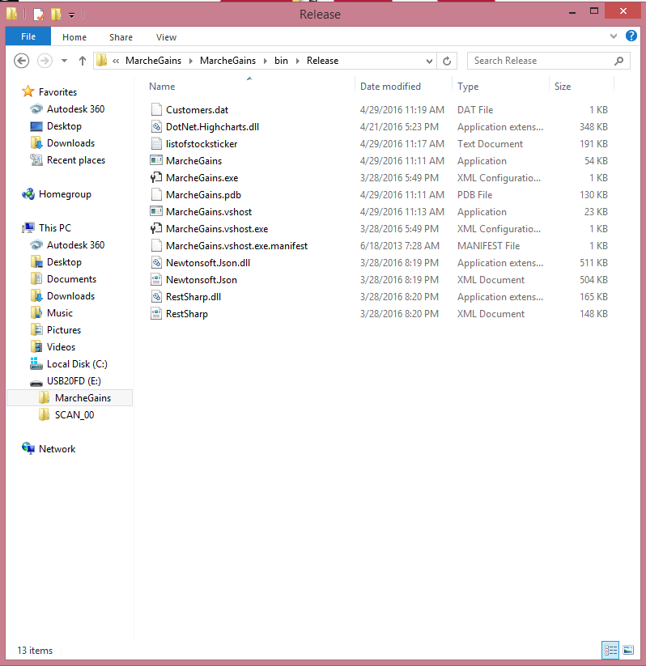

* 1. Open the “MarcheGains” application file.
  2. Program will then launch.

1. MarcheGains User Manual
   1. Register an account with MarcheGains.

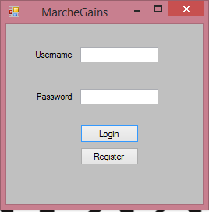

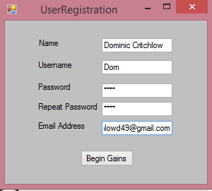

* 1. Click “Begin Gains” button to move to next form.

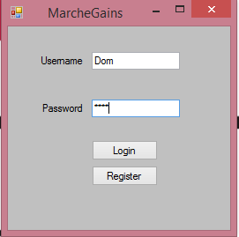

* 1. Login to MarcheGains account using the associated credentials.

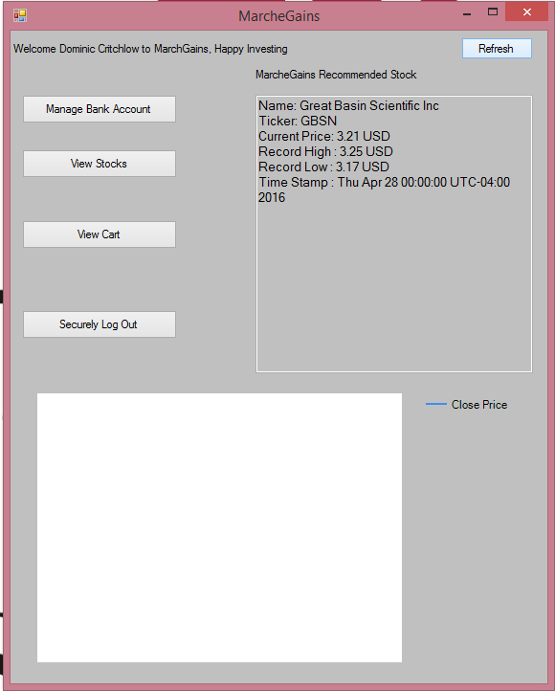

* 1. After completing the login procedure, you must create a new bank account with MarcheGains.

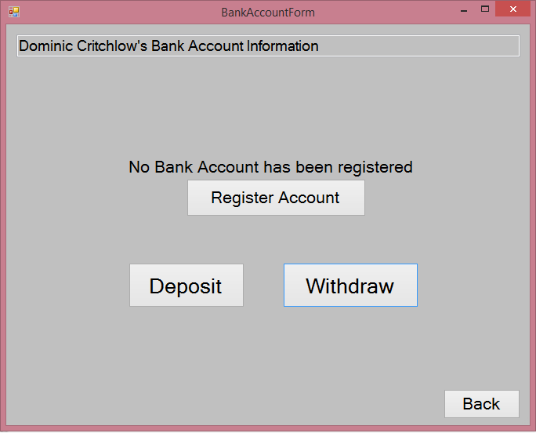

* 1. To do so, click the “Register Account” button.

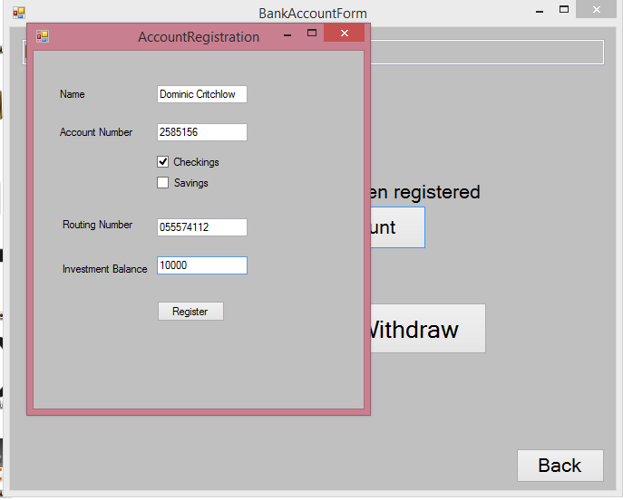

* 1. Fill out the appropriate boxes using your information.
  2. Click the “Register” button to complete all changes.

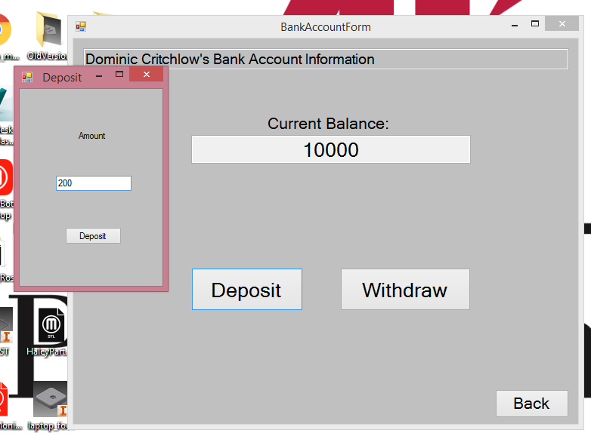

* 1. After registering a bank account with MarcheGains, you will be able to deposit and withdraw funds from your MarcheGains bank account.

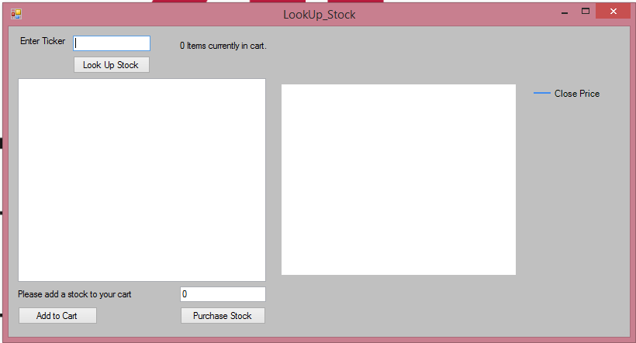

* 1. You can now begin the process of finding and adding stocks to your MarcheGains account.
  2. Enter the ticker symbol into the “Enter Ticker” text box and click the “Look Up Stock” button.
  3. After entering the appropriate stock ticker, you must wait approximately five (5) seconds for MarcheGains to produce the needed information.
  4. You may now add the stock to your MarcheGains account using the “Add to Cart” button.

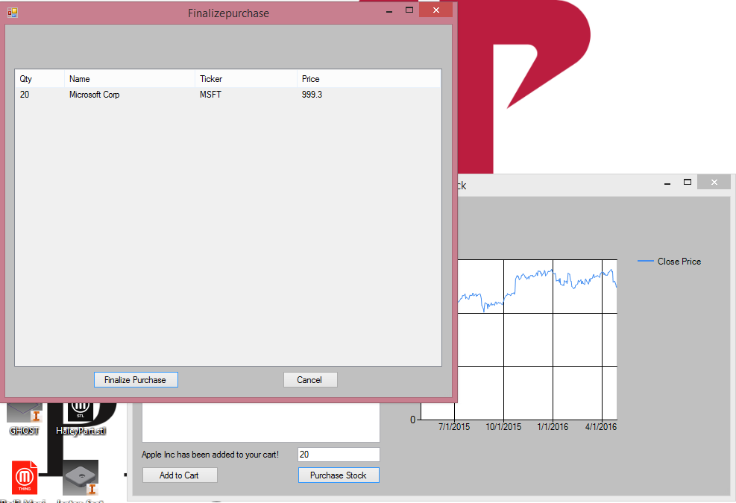

* 1. You can also purchase the input stock directly by entering the desired quantity and clicking the “Purchase Stock” button.
  2. You are then brought to the FinalizePurchase screen where you may finalize your purchase and inform your advisor of the purchase.

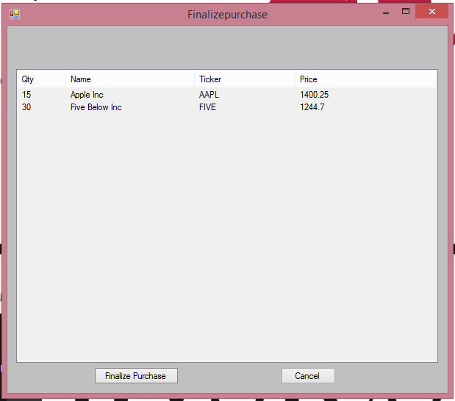

* 1. After clicking the “Finalize Purchase” button, an email containing the appropriate stock information as well as banking information will then be sent to both you and your advisor for purchase.